Experiment 9
Analysis of the Effect of Dielectric Material on Transmission Line Characteristics
Teast case 1 :
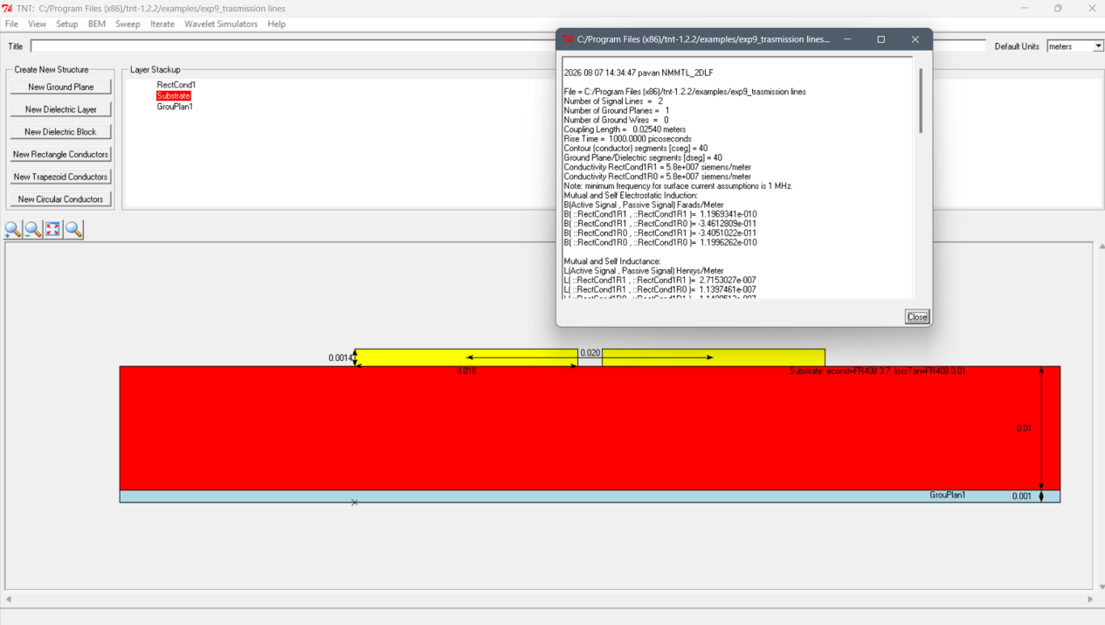
Test case 2: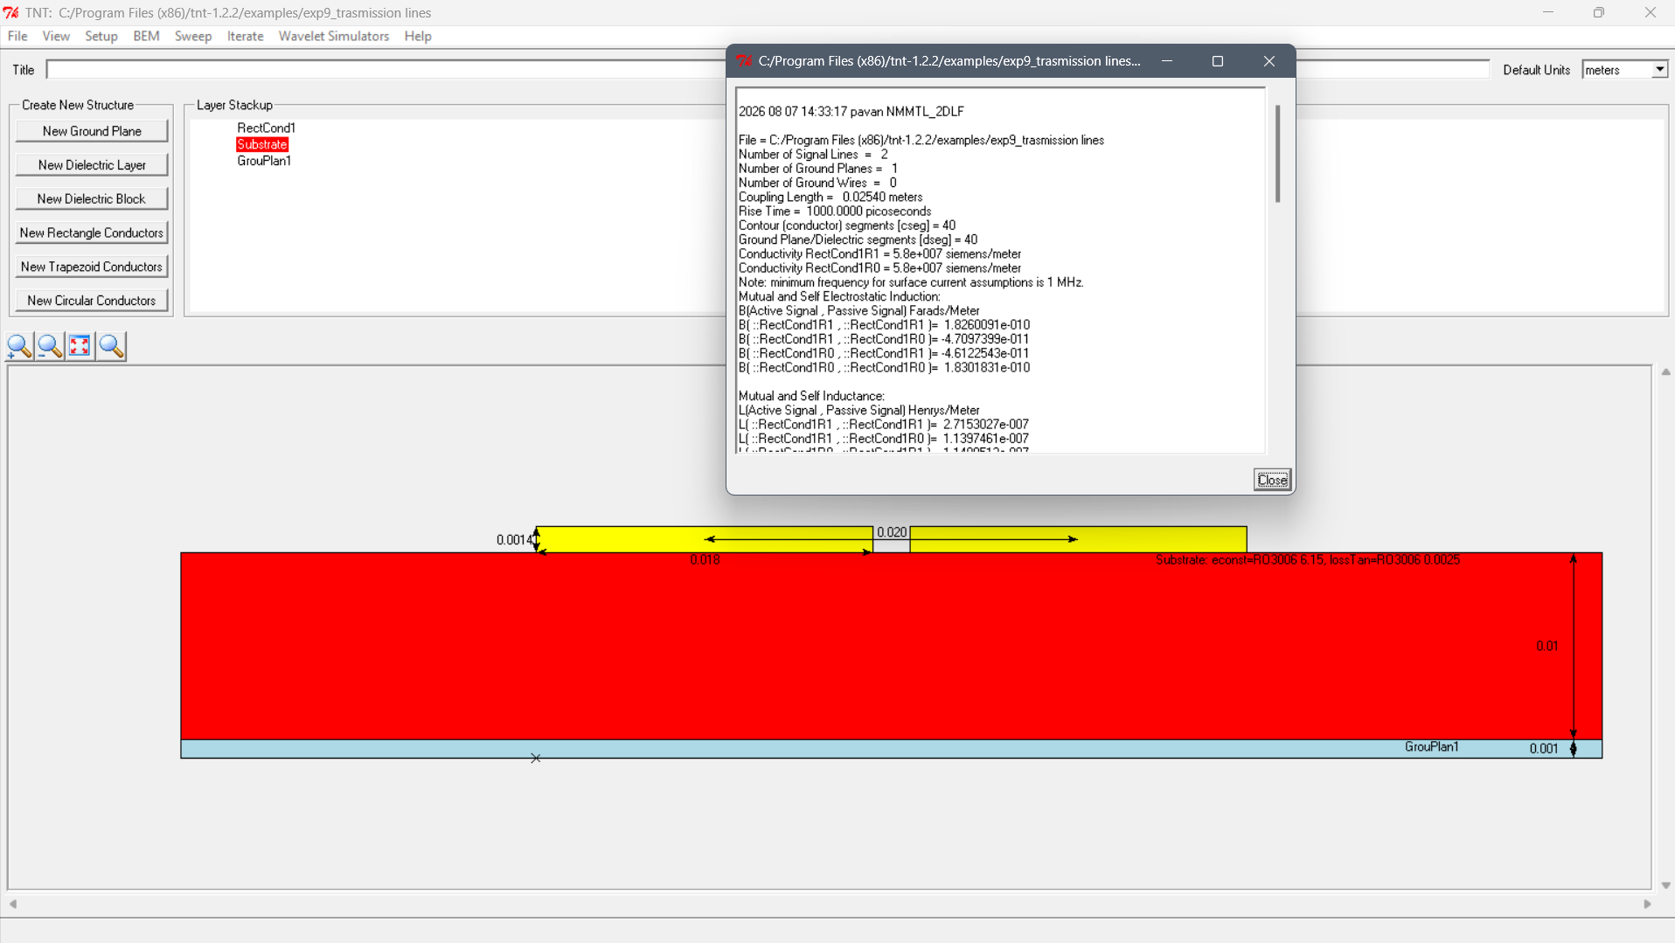
Testcase 3 : 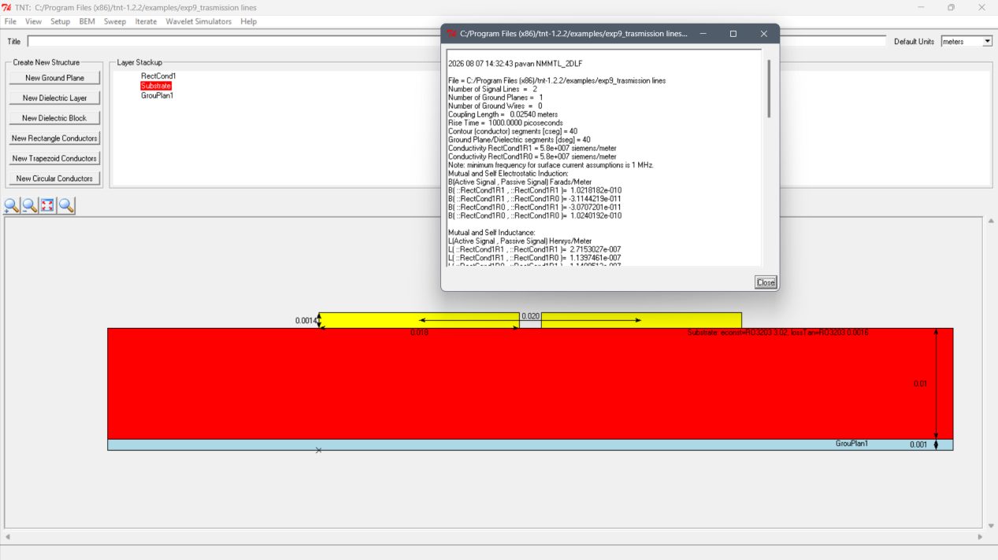
Test case 4 :

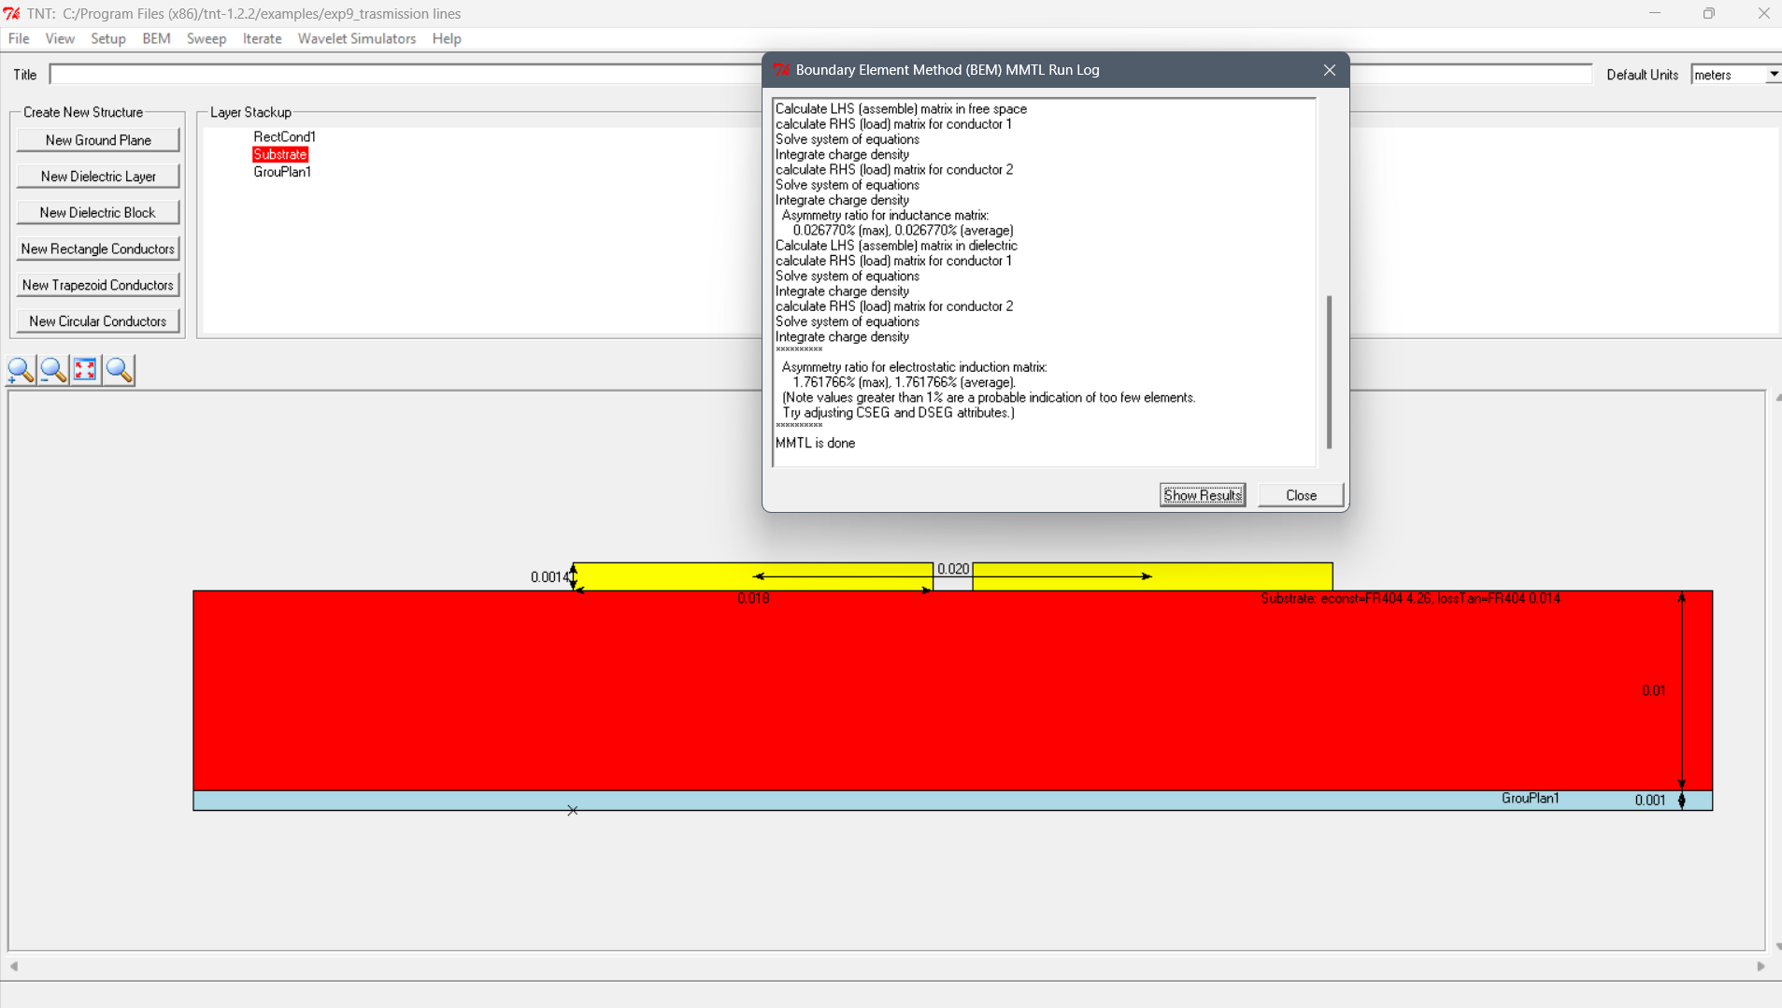
Test case 5 : 